 **VELAMMAL BODHI CAMPUS **

**GRAND TEST –IV (2023-2024)**

**CLASS: X BATCH II MARKS: 80**

**SUBJECT: SCIENCE (BATCH-II) DURATION: 3Hrs**

*********************************************************************************************

General instructions:

i. This question paper consists of 39 questions in 5 sections

ii. All questions are compulsory however and internal choices is provided in some questions a students is expected to attend only one of these questions

iii. Section A consist of 20 objective type questions carrying 1 mark each

iv. Section B consist of 6 VERY SHORT questions carrying 02 mark each. Answer to these questions should be in the range of 30 t0 50 words.

v. Section C consist of 7 SHORT questions carrying 03 mark each. Answer to these questions should be in the range of 50 t0 80 words

vi. Section D consist of 3 long questions carrying 05 mark each. Answer to these questions should be in the range of 80 t0 120 words.

vii. Section E consist of 3 SOURCE/CASE Based units of assessment of 04 marks each with sub parts.

**I. Answer the following questions.**

1. A student learns that magnetic field strength around a bar magnet is different at every point. Which diagram shows the correct magnetic field lines around a bar magnet?

|  |  |
| --- | --- |
|  |  |
|  |  |

2. The mirrors used in torches, search lights and vehicle headlights to get powerful parallel beam of light are

a) Convex mirror b) Convex lens

c) Concave mirror d) Concave lens

3. Observe the given figure and identify the correct statements.

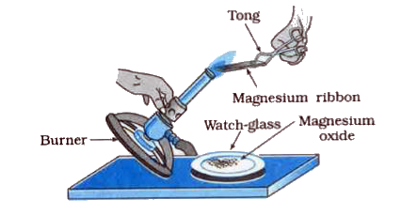

1. Magnesium ribbon burns in air with a dazzling white flame
2. It is a displacement reaction
3. Magnesium oxide is basic in nature and turns moist red litmus paper blue
4. It is an exothermic reaction
5. (i) and (iii) b) (ii) and (iv) c) (i) and (iii) and (iv) d) (i) and (iv)

4. Identify the correct oxidant and reductant in the following reaction

PbS +4H2O2 → PbSO4 + 4H2O

a) PbS – Oxidant: H2O2 – reductant b) PbS – reductant : PbSO4 – Oxidant

c) PbS – reductant : H2O2 – Oxidant d) H2O2 – Oxidant: H2O – reductant

5. Given below is a reaction showing chlor-alkali process

2NaCl + 2H2O → 2NaOH + Cl2 + H2

1. (B) (C)

The products A,B, and C are produced respectively

1. At the anode, at the cathode, near the cathode
2. Near the cathode, at the anode, at the cathode
3. At the cathode, near the cathode, at the anode
4. At the anode, near the cathode, at the cathode

6. In the activity shown in the diagram, if the climate is humid, the role of the calcium chloride taken in the guard tube is to

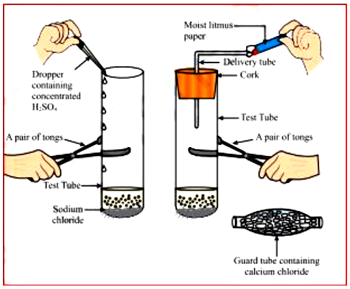

a) Absorb the evolved gas b) Warm up the gas

c) Dry the gas d) Absorb chloride ions from the evolved gas

7. **Which of the following pairs will give displacement reactions?**

**(a) NaCl solution and copper metal**

**(b) MgCl2 solution and aluminium metal**

**(c) FeSO4 solution and silver metal**

**(d) AgNO3 solution and copper metal**

**8. Metals are refined by using different methods. Which of the following metals are not refined by electrolytic refining?  
(i) Au (ii) Cu (iii) Na (iv) K**

**a) (i) and (ii) b) (i) and (iii) c) (ii) and (iii) d) (iii) and (iv)**

**9. Which of the following statements is not correct?**

**a) A common functional group is present in different members of a homologous series**

**b) Two consecutive members of homologous series differ by a – CH3 group.**

**c) The members of homologous series can be represented by one general formula**

**d) Different members of a homologous series have similar chemical properties**

10. Observe the given diagram and identify the organism with the type of reproduction

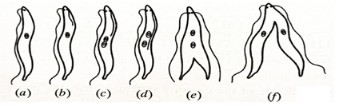

a)Binary fission in Paramecium b)binary fission in leishmania

c)binary fission in planaria d)binary fission in euglena

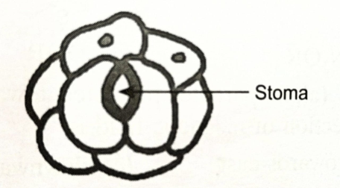11. A student has drawn the diagram of stomata as shown below in a hurry he could not be given full marks as he

a) forgot to draw nuclei in guard cell and also to label the diagram

b) did not drawn nuclei in guard cells and the other cells

c) should have drawn nuclei and chloroplast in guard cells and nuclei in all epidermal cells

d) did not label the stoma in the correct position

12. Reflex arc is formed by

a) muscle 🡪 brain 🡪 receptor b) muscle 🡪 spinal cord 🡪 receptor

c) receptor 🡪 brain 🡪 muscle d) receptor 🡪 spinal cord 🡪 muscle

13. A dihybrid cross between two pure breeding recessive parents has been given below RRyy × rrYY. Which of the following would be the genotype of the F1 generation

a) RrYy b)RrYY c)RRyy d)rryy

14. Xylem helps in _.

a) transportation of water b) translocation of food

c) both a and b d) transportation of water and minerals

15. Which part of the alimentary canal receives bile from the liver –

A) stomach B) small intestine

C) large intestine D) oesophagus

16. The % of solar radiation absorbed by all green plants for photosynthesis is about ——

A. 1% B. 5% C. 8% D. 10%

**Q.NO: 17 to 20 Assertion and Reason type questions.**

a. both reason and assertion are correct statement and reason is the correct explanation of assertion

b. both reason and assertion are correct statement but reason is not the correct explanation of assertion

c. assertion is correct but reason is wrong

d. Both assertion and reason are wrong.

17. Assertions (A): We should use the resources of nature carefully because both nature and living organisms are dependent on each other.

Reasons (R): A perfect balance is required between Nature and the Human Environment.

18. Assertion (A): Variations are seen in offspring produced by sexual reproduction.

Reason (R): DNA molecule generated by replication is not exactly identical to original DNA.

19. Assertion (A): On changing the direction of the flow of current through a straight conductor, the direction of a magnetic field around the conductor is reversed.

Reason (R): The direction of the magnetic field around a conductor can be given in accordance with the left-hand thumb rule.

**20. Assertion (A) : Esterification is a process in which a sweet smelling substance is produced**

**Reason ( R ) : when esters react with sodium hydroxide, an alcohol and sodium salt of carboxylic acid are obtained.**

**SECTION -B**

21. Draw a diagram to show the dispersion of white light by a glass prism.

(or)

Why do we prefer a convex mirror as a rear-view mirror in vehicles?

22. Why are filaments of incandescent lamps made of thin tungsten wire?

23. Identify the substances that are oxidized and the substances that are reduced in the following reactions:

i) 4Na(s) + O2(g) → 2Na2O(s)

ii) CuO(s) + H2(g) → Cu(s) + H2O(I)

24. Name the hormone secreted by human testes state its functions

25. Explain the process of nutrition in amoeba

26. In the following food chain only 2J of energy was available to the peacocks how much energy would have been present in grass justify your answer

Grass ->grasshopper-> frog-> snake-> peacock.

**SECTION -C**

27. An electric heater rated 800 W operates 6h/day. Find the cost of energy to operate it for 30 days at Rs. 3.00 per unit.

28. What are permanent magnet and electromagnets? Give two uses of each.

29. If the image formed by a mirror for all positions of the object placed in front of it is always diminished, erect and virtual, state the type of the mirror and also draw a ray diagram to justify your answer. Write one use such mirrors are put to and why?

30. Take 3 g of barium hydroxide in a test tube, add about 2 g of ammonium chloride and mix the contents with the help of a glass rod. Now touch the test tube from outside.

i) What do you feel on touching the test tube?

ii) State the inference about the type of reaction occurred.

iii) Write the balanced chemical equation of the reaction involved.

31. An ore on treatment with dilute hydrochloric acid produces brisk effervescence. Name the type of ore with one example. What steps will be required to obtain metal from the enriched ore? Also write the chemical equations for the reactions involved in the process.

32. Name the diseases by which a person is likely to suffer due to the deficiency of:

(i) Iodine; (ii) Insulin

(b) How the timing of secretion and amount of hormone secretion are regulated in human system. Explain with example.

33. How is the sex of the child determined in human beings?

**SECTION -D**

34. (a) One-half of a convex lens is covered with a black paper. Will such a lens produce an image of the complete object? Support your answer with a ray diagram.

(b) An object 5 cm high is held 25 cm away from a converging lens of focal length 10 cm.

(i) Draw the ray diagram and

(ii) Calculate the position and size of the image formed.

(iii) What is the nature of the image?

(or)

Draw ray diagrams showing the image formation by a concave mirror when an object is placed

(a) Between pole and focus of the mirror

(b) Between focus and centre of curvature of the mirror

(c) At centre of curvature of the mirror

(d) A little beyond centre of curvature of the mirror

(e) At infinity

35. (a) State the reason why carbon can neither form C4+ cations nor C4- anions, but forms covalent bonds. Also state reasons to explain why covalent compounds

(i) Are bad conductors of electricity

(ii) Have low melting and boiling points

b) Write the structural formula of benzene C6H6.

(or)

a) What are micelles? Why does it form when soap is added to water?

b) Will a micelle be formed in other solvents such as ethanol also?

c) State briefly how the formation of micelles help to clean the clothes having oily spots.

36. a) what are unisexual flower give two examples .what type of pollination seen in such flowers? name two pollinating agents b)draw longitudinal section of flower and label

i) female reproductive part ii) Male reproductive part

iii) non reproductive part

(OR)

a) With the help of diagram show the different stages of binary fission in amoeba

b)How do plasmodium and leishmania reproduce write one difference in their mode of reproduction

c)why are budding fragmentation and regeneration all considered as asexual type of reproduction?

**SECTION -E**

37. When electric current flows through the circuit this electrical energy is used in two ways, some part is used for doing work and remaining may be expended in the form of heat. We can see, in mixers after using it for long time it become more hot, fans also become hot after continuous use. This type of effect of electric current is called as heating effect of electric current. If I is the current flowing through the circuit then the amount of heat dissipated in that resistor will be H = VIt

This effect was discovered by Joule, hence it is called as Joule’s law of heating.

Also, we can write, H = I2Rt

Thus, heat produced is directly proportional to the square of the electric current, directly proportional to the resistance of the resistor and the time for which electric current flows through the circuit. This heating effect is used in many applications. The heating effect is also used for producing light. In case of electric bulb, the filament produces more heat energy which is emitted in the form of light. And hence filament are made from tungsten which is having high melting point.

In case of electric circuit, this heating effect is used to protect the electric circuit from damage.

The rate of doing work or rate of consumption of energy is called as power. Here, the rate at which electric energy dissipated or consumed in an electric circuit is called as electric power. And it is given by P= VI

The SI unit of electric power is watt.

(i) What is the SI unit of electric energy?

(ii) How heating effect works to protect electric circuit?

(iii) 1KW h = ?

(iv) If a bulb is working at a voltage of 200V and the current is 1A then what is the power of the bulb?

38. Carbon has the unique ability to form bonds with other atoms of carbon, giving rise to larger molecules. This property is called catenation. Carbon has valency 4 and if all the four valencies are satisfied by single bonds then these compounds are called saturated compounds and if carbon forms double and triple bonds then these compounds are known as unsaturated compounds.

i) Which of the following represent saturated hydrocarbons?

1. CH3C≡CH3 2. CH2=CHCH3

3. CH3CH(CH3)CH2CH3 4. (CH₃)₂C=CHCH3

a) 3 only b) 2 and 4 only

c) 1, 2 and 3 only d) 1, 2, 3 and 4

ii) Three hydrocarbons X, Y and Z are shown below:

X: CH3 CH2 CH2 CH2 CH3

Y:CH3-C≡C-CH2CH3

Z: CH3CH2-CH=CH-CH3

Identify the incorrect statements about these three hydrocarbons.

I. X and Y both differ by a-CH, unit.

II. X and Z have the same boiling point.

III. All have different general formulae.

IV. Y and Z have different molecular masses.

a) I and II b) II and III

c) I and IV d) All the statements are incorrect.

iii) Which of the following compounds has a triple bond?

(a) C2H4 (b) C3H4 (c) C3H8 d) C4H10

iv) The structural formulae of four hydrocarbons are shown below:

|  |  |
| --- | --- |
| 1) CH3CH=CHCH3 | 2) CH3−C−CH3  CH2 |
| 3) CH2=CHCH2CH3 | 4) |

Which structural formula represent alkenes?

a) 1 and 2 b) 2 and 3

c) 1,2 and 3 d) 1,2,3 and 4

39. Pure bred pea plant with smooth seeds (dominant characteristic) were crossed with pure bred pea plant with wrinkled seeds (recessive characteristic). The F1 generation was self pollinated to give rise to the F2 generation.

(a) What is the expected observation of the F1 generation of plants?

(b) What is the expected observation of the F2 generation of plants?

(c) What will be the phenotypic ration of F1 offspring?

(d) What will be the genotypic ration of F2 offspring, also mention whether it will be homozygous or heterozygous?